# CSE 11 Programming Assignment 1

**Name (Last, First):** *Rivett, Max*

**PID:** *A16885138*

**Email:** *mrivett@ucsd.edu*

## Setup:

I am using Java 16.0.2, which I downloaded by following the instructions highlighted in *Part 1* of the *CSE 11 Programming Assignment 1* webpage. This involved using the JDK installer and checking my Java version in the command line.

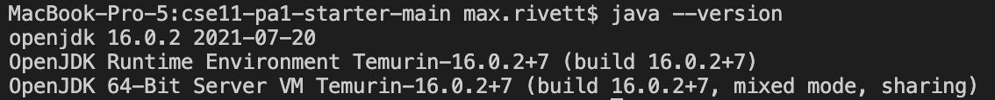

I am using Visual Studio Code (VSC) as my code editor mainly due to the ability to run the program from a built-in terminal window, but also due to the overall sleekness of the application. I downloaded VSC several years ago, likely from their webpage at <https://code.visualstudio.com/>.

## Running Code:

## Issues:

N/A